St. Patrick’s
Religious Education
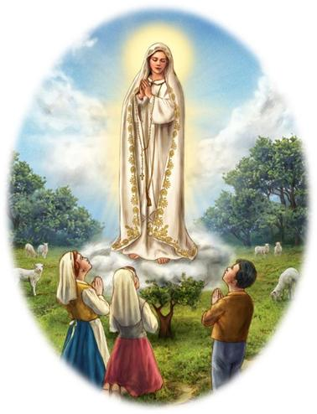

2019-2020
Parent Handbook

Welcome to the 2019-2020 Religious Education Year!

May the peace of Christ be with you!
We look forward to working with you and the Holy Spirit throughout
the year to further develop the love of God and
the knowledge of the faith in the children of St. Patrick’s Parish.

God bless you this year and always,
Ashley Dush, DRE, & St. Patrick’s Catechists

Mission Statements:
St. Patrick’s Church: We are a stewardship community ever attempting to grow in Jesus Christ by fidelity to the incomparable means he gives us through the Catholic Church.

St. Patrick’s Religious Education Program:
From the Catechism of the Catholic Church…
Catechesis aims at putting “people…in communion…with Jesus Christ: only he can lead us to the love of the Father in the Spirit and make us share in the life of the Holy Trinity.”
-CCC 426

The Purpose of the St. Patrick’s Religious Formation Program:
To assist parents in the religious formation of their children by setting before them Christian adults who, by their commitment to service in the church, will inspire and promote opportunities which will lead the young to faith in Jesus Christ. To inspire and assist young people to choose to live their faith in the Catholic Church. To motivate adults/parents to increase and enrich their faith in God and the Church so they can be witnesses of Gospel love, justice and mercy to their families and the Church as a whole.

Goals of Saint Patrick’s Religious Education Program:
- To form disciples of Jesus Christ
- To provide our young people with knowledge of the Faith
- To provide our young people with knowledge of the meaning of the Liturgy and the Sacraments
- To provide our young people with a moral formation in Jesus Christ
- To teach our young people how to meet Christ in prayer
- To prepare our young people to live in community and to participate actively in the life and mission of the Church
- To promote a missionary spirit that prepares our young people to be present as Christians in our society

Curriculum:

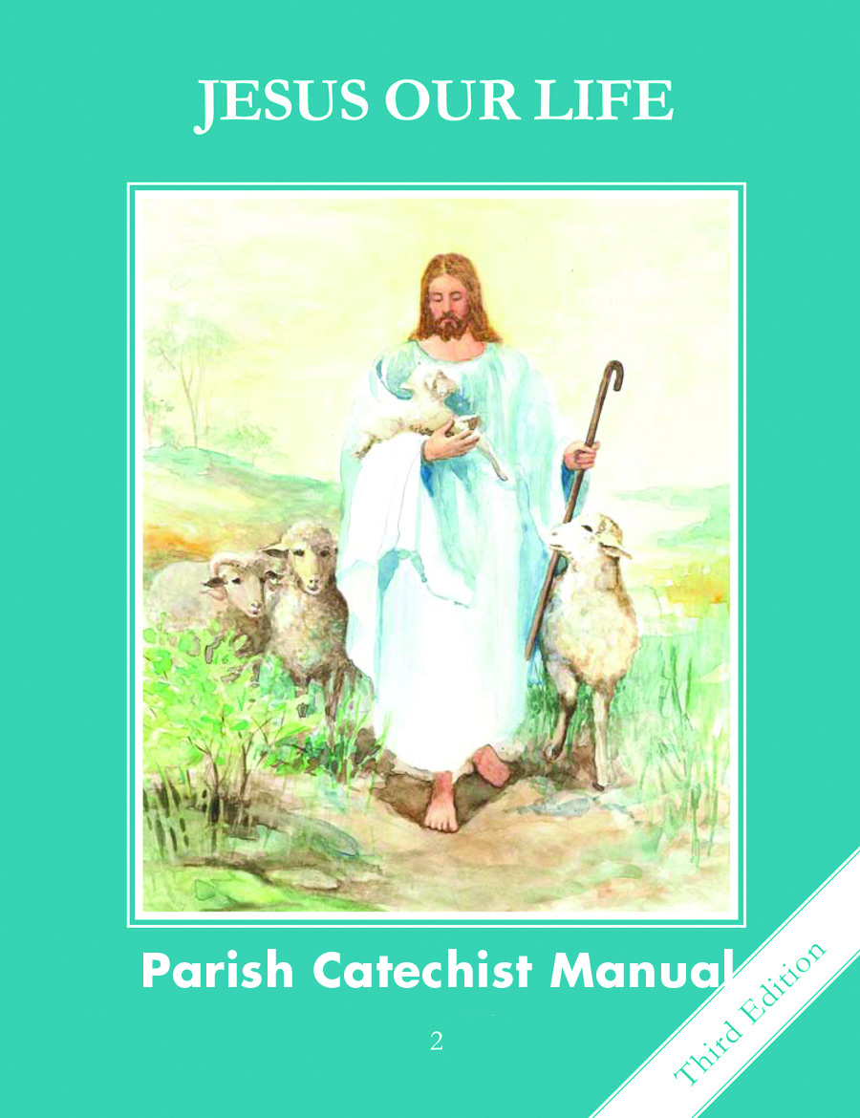
Pre-K & Kindergarten- Image of God

1st-6th grade- Faith and Life Series

7th-8th grade- Encounter by Mark Hart, Anima Series from formed.org, Altaration by Ascension Presents

9th-12th grade- Anima Series from formed.org, Theology of the Body, Decision Point, The Teen Timeline



St. Patrick’s Religious Education

- Students in grades Pre-K- 6th grade will meet on Wednesday nights from 5:30pm-6:45pm.
We begin in a large circle in the Pelican Room of the Spiritual Life Center and pray as a whole group. At that point, Ashley Dush, DRE, will share about different liturgical celebrations, Saints, knowledge on the Church and any announcements. Students will head back to class around 5:40pm to begin their lessons.

- Students in grades 7th-12th will meet each Wednesday from 7:00pm-8:15pm in the Spiritual Life Center and the Parish Hall.

- Confirmation Students will meet each Wednesday from 7:00-8:30pm in the Spiritual Life Center.

Jesus said, "Let the
little children come to me, and do not hinder them, for the kingdom of heaven belongs to such as these."
-Matthew 19:14-

Middle School Religious Education
Theme: Encounter

This year the teens will learn and experience the many different ways we can encounter our Lord, whether that be through the sacraments, prayer, in others, community, etc.
They will connect this theme with the
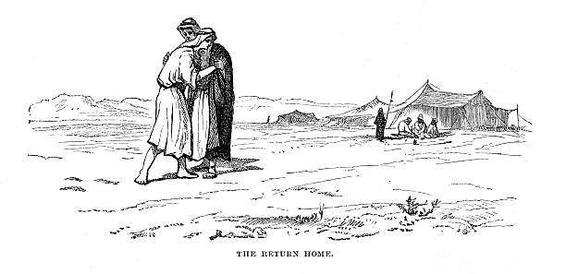
story of the Prodigal Son.
-Luke 15:11-32-
You won’t want to miss out!

High School Religious Education
Theme:
“What are you looking for?”

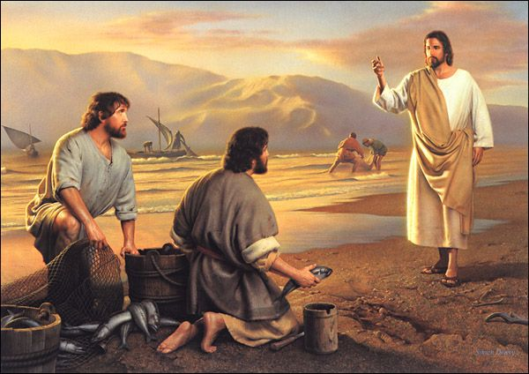
This year the teens will explore within their hearts and in the classroom the question the Lord asks the disciples before they choose to follow him, “What are you looking for?”
-John 1:37-40-
Come, bring a friend and enjoy!

Notes on RE at St. Pat’s

Every Wednesday we offer Eucharistic Adoration from 5:30-6:30pm & 7:30-8:30pm. Parents and families, please join us!

Expectations/Policies
For all families in our RE program, please note that our program is mostly funded by your tuition fees, but parish tithing and volunteer effort is the greatest support for our work with your children. Weekly attendance to RE classes and attending Mass on Sunday, as well as your personal commitment to the Stewardship of our Parish (time, talent & treasures) are all necessary components of participating in our Religious Education program. We invite you to engage in prayer as a family in your home as well.

Important Guidelines and Responsibilities:
- Attendance- Please bring your child to class each week, especially if they are in Sacramental preparation classes.
- Toys, phones, laptops, etc. are NOT allowed to be used during RE classes.
- Students need to use the bathroom before or after class to avoid leaving class during the lesson.

Discipline Policies
- The Catechist will handle all minor problems in the classroom.
- The DRE or priest will be asked to observe/aide the Catechist and/or student within the classroom.
- If behavior persists, the catechist can dismiss the child from the classroom and sent to the DRE, Ashley Dush, or the priest.
- Student will return to class when DRE or priest believes they are ready. They will apologize to Catechist privately.

In case of sustained misbehavior, the following steps must be taken:

- After steps 1-4 have been followed, the student will call their parent and tell them they have been removed from the classroom and why (Student will be on speaker phone with DRE or priest).
- Parent will meet with DRE and catechist to address behavior.
- Parent will attend the next class with their child.
- If behavior persists, another meeting will be held with priest, parents and catechist to take final decisions on their child’s religious education options.

Social Media Safety Policy

With the new social media sites, we may post some pictures of the kids to advertise our program. The safety policy is to never have 3 forms of information on the same site, i.e. picture, name, and location. We will never post your child’s name with their picture. If you did not sign our registration form agreeing to this, your child’s image will not be used on the web.

Drop Off & Dismissal
- Classes meet in the Spiritual Life Center. For parents with child ages PreK-6th grade, please come inside to drop off and pick up your child. We need to have you sign them in and sign them out. This is a safety precaution taken to ensure all students are kept in optimal safety at St. Pat’s.
- Please do not drop students off any sooner than 5:00pm.

Cancellations
- In the event of severe weather, classes may be cancelled. Keep watch on Facebook and on the myParish app for alerts.
- If school is not in session on a Wednesday or school is not in session the Thursday or Friday following, we will be cancelling Religious Ed classes.
  - See calendar for specific days we are not having RE classes

Weekly Announcements
Informational notes from the DRE or priests, reminders, faith building activity sheets, or letters from your Catechist will be sent home at any given time. Please ask your child each week if he/she was given a flier or note. This will help us stay in communication with you.

St. Patrick’s Religious Education Catechists
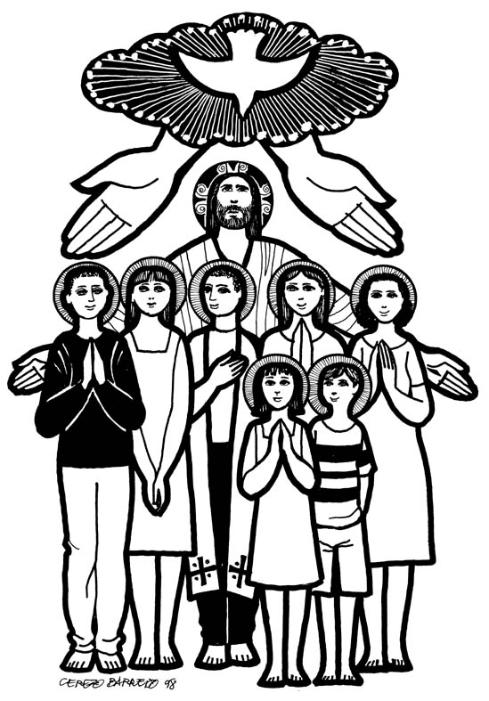
Pre K: Mikala Miller
Kindergarten: Dawn Erdman
1st grade: Laura Lee
2nd grade- Sacramental Preparation:
Tad Pfeifer, Tristen Winder & Michelle Whips
3rd grade: Lynette Powers
4th grade: Adam Rhoades
5th/6th grade: Erlinda Scovill & Donna Obermeier
7th/8th grade:
Teresa Helie, Cat Urrutia & George Campbell
9th-12th grade:
Makaela Barron, Amber Thomas, & Gilbert Seck
Confirmation:
Deacon Matt & Mellissa Irish & Deacon Dixon Powers
RCIA For Kids:

Parish Staff
Pastor -
Fr. Josh Brown
308-532-0942 ext. 202
frjosh@st-pats-online.org
Parochial Vicar –
Fr. Vijuman Choorackal
308-532-0942 ext. 210
vchoorackal@gmail.com
Director of Religious Education-
Ashley Dush
308-532-0942 Ext. 203
religioused@st-pats-online.org
Stewardship & Hospitality–
Kira Dimas
308-532-0942 Ext. 211
formation@st-pats-online.org
Sacramental Programs
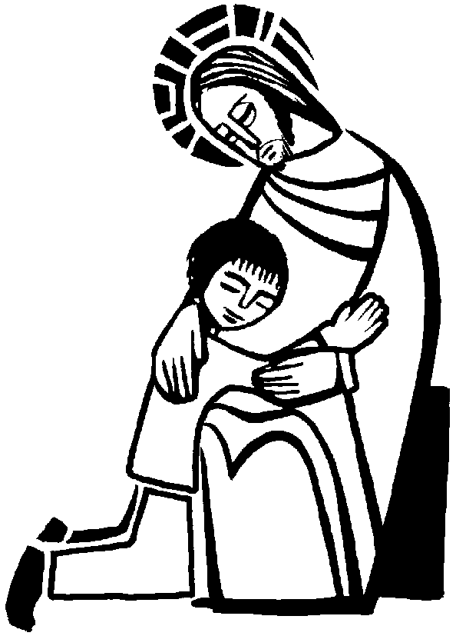
Children will begin preparation for the Sacraments of Reconciliation & First Communion sacraments in the 2nd grade.

First Reconciliation: Penance is the sacrament by which we receive God’s healing forgiveness for sins committed after baptism. The rite is called reconciliation because it reconciles us back to God but also with the Church community.

First Eucharist: First Eucharist is the sacrament by which we receive Christ: body, blood, soul and divinity. “The Eucharist is "the source and summit of the Christian life." "The other sacraments, and indeed all ecclesiastical ministries and works of the apostolate, are bound up with the Eucharist and are oriented toward it. For in the blessed Eucharist is contained the whole spiritual good of the Church, namely Christ himself, our Pasch." -CCC 1324
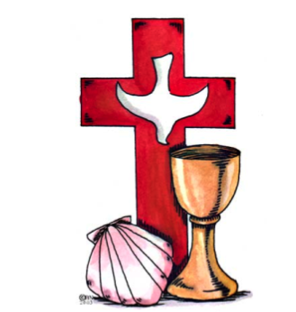
RCIC- Rite of Christian Initiation of Children:
Do you have a child that missed their 2nd grade sacramental preparation and needs to receive the sacraments of Reconciliation and First Communion?
For Children in the 4th grade and above who have not received the sacraments of Reconciliation and First Eucharist will be asked to attend a supplemental class accompanying their grade level catechism classes. On specific Wednesday’s of each month the student participating in the RCIC classes will be removed from the class they regularly attend and will meet with a catechist in the Pelican Room of the Spiritual Life Center. They will receive sacramental formation during this time preparing them to receive the sacraments of Reconciliation and First Communion this coming spring along with the 2nd grade sacramental prep class.

Confirmation
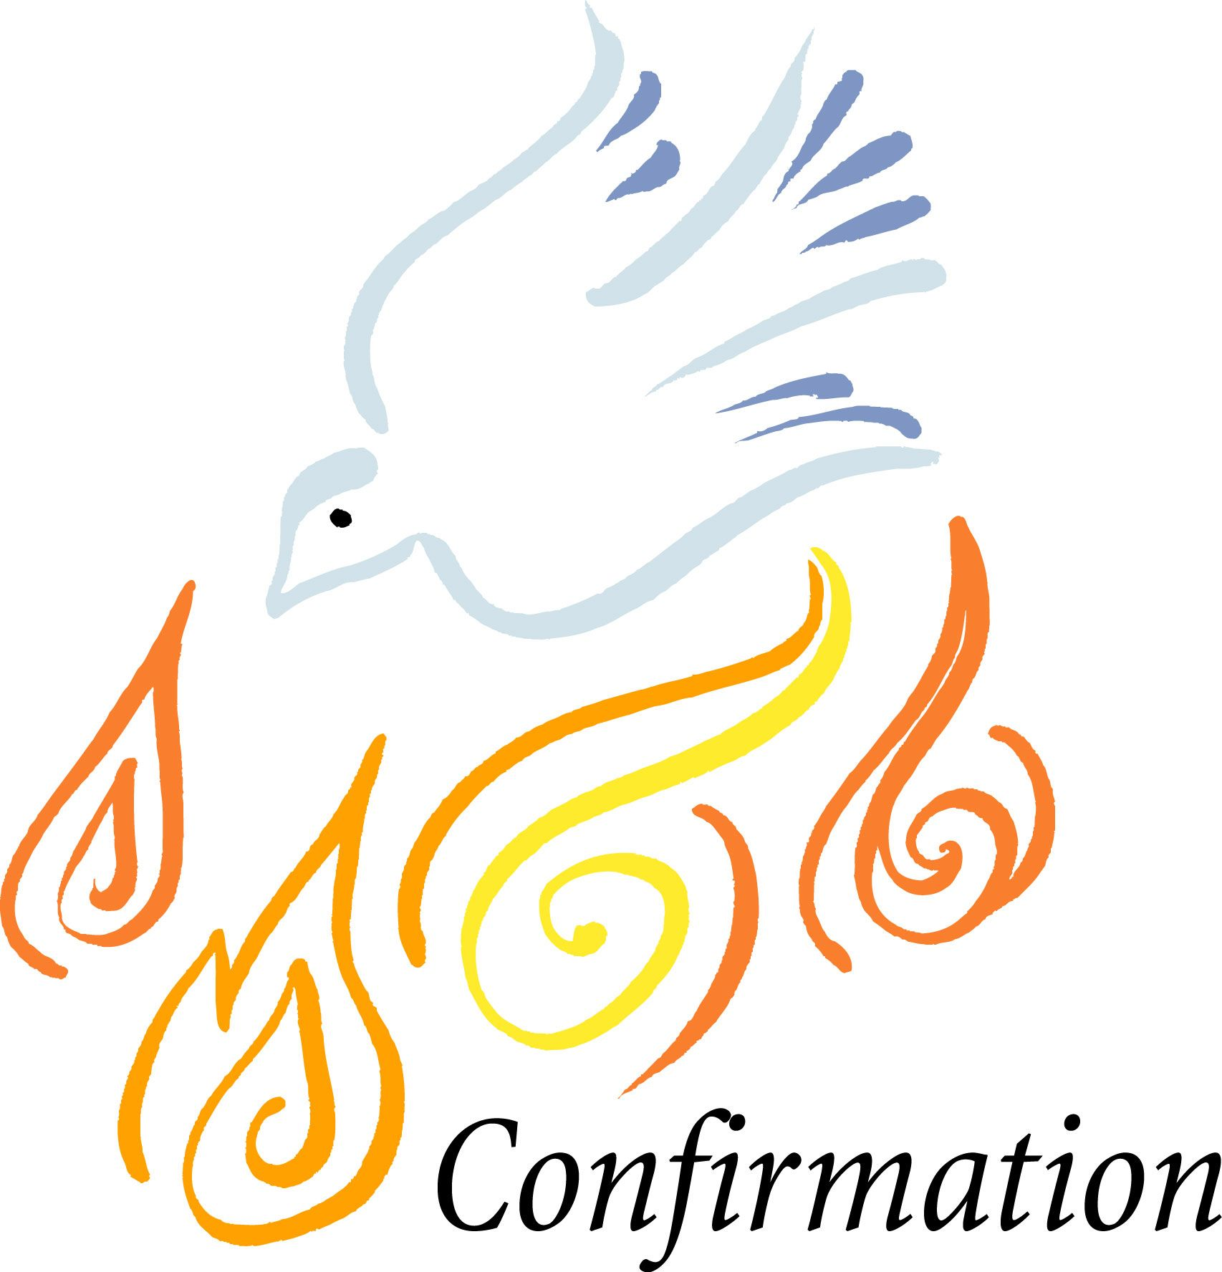
Confirmation: “Baptism, the Eucharist, and the sacrament of Confirmation together constitute the "sacraments of Christian initiation," whose unity must be safeguarded. It must be explained to the faithful that the reception of the sacrament of Confirmation is necessary for the completion of baptismal grace. For "by the sacrament of Confirmation, [the baptized] are more perfectly bound to the Church and are enriched with a special strength of the Holy Spirit. Hence they are, as true witnesses of Christ, more strictly obliged to spread and defend the faith by word and deed.” – CCC 1285.

Confirmation Formation classes are held each Wednesday night from 7:00pm – 8:30pm in the Spiritual Life Center. Any child going into 10th grade is invited to begin the intensified Confirmation preparation classes. Any child in the 9th grade is asked to begin their confirmation preparation by attending our High School Religious Education classes. This invites the child to learn how to grow in relationship with Christ and his Church before choosing to be Confirmed the year following.

If you have a student who is entering 10th grade, please contact Ashley Dush for more information on the Confirmation program and requirements.
Suggested Prayers
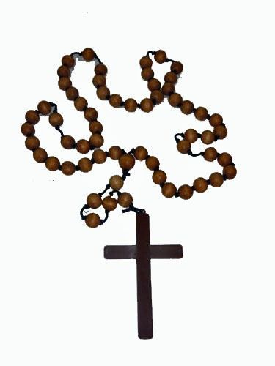
Rote prayers such as the Hail Mary, Glory Be, etc., as well as different parts of the faith/Church such as the Precepts of the Church or the Beatitudes are wonderful spiritual tools to have on our faith journey. Here are a few suggestions and tools for you to help strengthen your child’s toolbox, that they can reach for at any time, any state in life. This is definitely not limited to all they can learn, these are truly just suggestions for what they can learn at each grade level. Please let me know if you have any questions or would like more resources!!

Pre – K:
- Sign of the Cross
- Hail Mary
- Grace before meals

Kindergarten: All the above and,
- Prayer After Meals
- Glory Be
- Our Father

1st grade: All the above and,
- Angel of God
- Morning Offering

2nd Grade: All the Above and,
- Act of contrition
- Prayer to St. Michael the Archangel
- What are Sacraments?

3rd Grade: All the above and,
The Rosary- All prayers included in
-Fatmia Prayer
-Hail Holy Queen

4th Grade: All the above and,
- Prayer to the Holy Spirit
- Ten Commandments
5th Grade: All the above and,
- Anima Christi
- Act of Faith

6th grade: All the above and,
- Act of Hope
- Act of Love
- Pillars of the Catholic Church

7th grade: All the above and,
- Beatitudes
- Understanding of Stewardship
- Stewardship Renewal Prayer

8th grade: All above and,
- The Way of the Cross
- Understanding Clergy and the Authority of the Church

High School: All the above and,
- Precepts of the Church
- Vocations Prayer

Confirmation: All of the above and,
- Understanding of the Saints
- Gifts of the Holy Spirit

List of Prayers

Our Father
Our Father,
Who art in heaven,
hallowed be Thy name;
Thy kingdom come;
Thy will be done on earth as it is in heaven.
Give us this day our daily bread;
and forgive us our trespasses
as we forgive those who trespass against us;
and lead us not into temptation,
but deliver us from evil. Amen.

Hail Mary
Hail Mary, full of grace. The Lord is with thee.
Blessed art thou amongst women,
and blessed is the fruit of thy womb, Jesus.
Holy Mary, Mother of God,
pray for us sinners,
now and at the hour of our death. Amen.

Glory Be
Glory be to the Father,
and to the Son,
and to the Holy Spirit,
as it was in the beginning,
is now, and ever shall be,
world without end. Amen.

Guardian Angel Prayer
Angel of God, my Guardian dear, to whom God's love commits me here, ever this day (or night) be at my side, to light and guard, to rule and guide. Amen.

Saint Michael Prayer
Saint Michael, the Archangel, defend us in battle.
Be our protection against the wickedness and snares of the devil.
May God rebuke him, we humbly pray;
and do thou, O Prince of the heavenly host,
by the power of God
cast into hell Satan and all the evil spirits
who prowl throughout the world seeking the ruin of souls. Amen.
Act of Contrition
Oh my God, I am heartily sorry for
having offended thee,
And I detest all my sins because
I dread the loss of heaven and
the pains of hell,
But most of all because they offend thee,
My God, Who are all good
and deserving of all of my love,
I firmly resolve,
with the help of Thy grace,
To confess my sins, to do penance,
And to amend my life.
Amen.

Grace Before Meals
Bless us, O Lord, and these Thy gifts, which we are about to receive from Thy bounty, through Christ our Lord. Amen.

Grace After Meals
We give Thee thanks for all Thy benefits, O Almighty God, who livest and reignest world without end. Amen. May the souls of the faithful departed, through the mercy of God, rest in peace. Amen.

The Apostle's Creed
I believe in God,
the Father Almighty,
Creator of Heaven and earth;
and in Jesus Christ, His only Son, Our Lord,
Who was conceived by the Holy Spirit,
born of the Virgin Mary,
suffered under Pontius Pilate,
was crucified, died, and was buried.
He descended into Hell.
The third day He arose again;
He ascended into Heaven,
and is seated at the right hand of God, the Father Almighty;
from thence He shall come to judge the living and the dead.
I believe in the Holy Spirit,
the holy Catholic Church,
the communion of saints,
the forgiveness of sins,
the resurrection of the body,
and life everlasting. Amen.

Hail Holy Queen
Hail, Holy Queen, Mother of mercy,
our life, our sweetness and our hope.
To thee do we cry, poor banished children of Eve:
to thee do we send up our sighs,
mourning and weeping in this valley of tears.
Turn then, most gracious Advocate,
thine eyes of mercy toward us,
and after this our exile,
show unto us the blessed fruit of thy womb, Jesus.
O clement, O loving, O sweet Virgin Mary! Amen.

Act of Faith
O my God, I firmly believe
that you are one God in three divine Persons,
Father, Son, and Holy Spirit.
I believe that your divine Son became man
and died for our sins and that he will come
to judge the living and the dead.
I believe these and all the truths
which the Holy Catholic Church teaches
because you have revealed them
who are eternal truth and wisdom,
who can neither deceive nor be deceived.
In this faith I intend to live and die.
Amen.

Act of Hope
O Lord God,
I hope by your grace for the pardon
of all my sins
and after life here to gain eternal happiness
because you have promised it
who are infinitely powerful, faithful, kind,
and merciful.
In this hope I intend to live and die.
Amen.

Act of Love
O Lord God, I love you above all things
and I love my neighbor for your sake
because you are the highest, infinite and perfect
good, worthy of all my love.
In this love I intend to live and die.
Amen
Beatitudes
- Blessed are the poor in spirit: for theirs is the kingdom of heaven.
- Blessed are the meek: for they shall possess the land.
- Blessed are they who mourn: for they shall be comforted.
- Blessed are they that hunger and thirst after justice: for they shall have their fill.
- Blessed are the merciful: for they shall obtain mercy.
- Blessed are the clean of heart: for they shall see God.
- Blessed are the peacemakers: for they shall be called the children of God.
- Blessed are they that suffer persecution for justice' sake, for theirs is the kingdom of heaven.

5 Precepts of the Catholic Church
- You shall attend Mass on Sundays and on holy days of obligation and rest from servile labor.
- You shall confess your sins at least once a year.
- You shall receive the sacrament of the Eucharist at least during the Easter season.
- You shall observe the days of fasting and abstinence established by the Church.
- You shall help to provide for the needs of the Church.

Seven Gifts of the Holy Spirit
- Wisdom
- Understanding
- Counsel
- Fortitude (or courage)
- Knowledge
- Piety
- Fear of the Lord

The Way of the Cross
1. Jesus is condemned to death.
2. Jesus bears His cross
3. Jesus falls the first time
4. Jesus meets his mother
5. Jesus is helped be Simon
6. Veronica wipes the face of Jesus
7. Jesus falls a second time
8. Jesus speaks to the women.
9. Jesus falls a third time.
10. Jesus is stripped of His garments
11. Jesus is nailed to the Cross
12. Jesus dies on the Cross
13. Jesus is taken down from the Cross
14. Jesus is placed in the tomb

The Ten Commandments
1. I am the Lord your God: You shall not have strange Gods before me.
2. You shall not take the name of the Lord your God in vain.
3. Remember to keep holy the Lord’s Day.
4. Honor your father and mother.
5. You shall not kill.
6. You shall not commit adultery.
7. You shall not steal.
8. You shall not bear false witness against your neighbor.
9. You shall not covet your neighbor’s wife.
10. You shall not covet your neighbor’s goods.

The Pillars of the Catholic Church
1. Creed
2. Prayer
3. Sacraments
4. Morality

The Morning Offering
O Jesus,
through the Immaculate Heart of Mary,
I offer You my prayers, works,
joys and sufferings of this day,
for all the intentions of Your Sacred Heart,
in union with the Holy Sacrifice of the Mass throughout
the world, in reparation for my sins,
for the intentions of all my relatives and friends,
and in particular for the intentions of the Holy Father,
Pope Francis. Amen.

Anima Christi
Soul of Christ, sanctify me.
Body of Christ, save me.
Blood of Christ, inebriate me.
Water from the side of Christ, wash me.
Passion of Christ, strengthen me.
O good Jesus, hear me.
Within Thy wounds, hide me.
Separated from Thee, let me never be.
From the malicious enemy, defend me.
At the hour of death, call me and keep me
Close to Thee bind, that with thy saints I
May be Praising Thee, forever and ever. Amen

Stewardship Renewal Prayer
Gracious God, I come to you in thanksgiving, knowing that all I am, and all that I have, is a gift from you.
In faith and love, help me to do your will. I am listening, dear Lord. Speak your words into the depth of my soul, that I may hear you clearly. I offer to you all the areas of my life, whether it be at home, at work, or at school, to be patient, merciful, generous, and to be holy. Give me the wisdom and insight to understand your will for me, and the fervor to fulfill my good intentions. I offer my gifts of time, talent and possessions to you, as a true act of faith to reflect my love for you, and my neighbor. Help me to reach out
to others, as you, my God, have reached out to me. In you holy name we pray. Amen.

myParish App


Join the myParish app & receive reminders from me throughout the year. You will request to join the “Religious Education for Parents and Youth”.

Please check the weekly bulletin each week for announcements and cancellations as well.

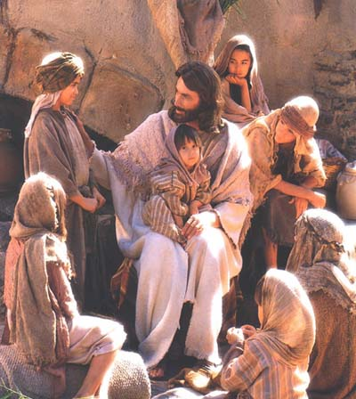
Thank you for sharing your faith
with your children and
entrusting us at St. Patrick’s
to serve your family
in this great task!

Ashley Dush
Director of
Religious Education
308-532-0942 ext. 203
religioused@st-pats-online.org

Parish Website:
st-pats-online.org

